A Review of 2000 Years of Christian History

6 BC-70 AD The Age of Jesus and the Apostles
This is a time period noted by the presence of Jesus and his close disciples establishing the Christian Church. The table of the Apostolic Age provides a general timeline. Various groups would have been impacted by one proclaiming to be the Messiah:
- Pharisees= scribes, who emphasized traditions (Jesus was viewed as a blasphemer)
- Sadducees= conservatives, politically minded (Jesus would upset the Roman status quo)
- Zealots= anti-Roman activists (Jesus failed to lead a revolt)
- Essenes= separated from society in a pre-monastery lifestyle
Jesus’ death meant different things to each of these groups. Pentecost in Acts 2:38 makes the origin of the Christian Church as empowered by the Holy Spirit. In this we see:
- Church begins the Great Commission actions required for discipleship
- Church leadership established through the Apostles and deacons (Stephen)
- Mandate given to share the gospel in Jerusalem-> Judea-> Samaria -> whole world
Jerusalem faithful (disciples/Apostles, etc.,) began using the O.T. word to describe themselves (ekklesia= gathering of people=church in English). Viewed by Jewish and Roman authorities as an offshoot (sect) of Judaism:
- Began ordinances of baptism and Lord’s Supper
- “Services” conducted on Lord’s Day (Sunday) before work
- Conducted in private homes or courts of the temple
- First martyrdom of the Church is reported in 36 AD. James and Stephen deaths noted
- Establishment of the office of the diaconate in the selection and laying on of hands
- Antioch established as a major hub of Christian effort
- By 44 AD Antioch believers were being called “Christians” as a slur
- Turkey/Asia Minor remained a key location for Christianity well into the 19th century
- Saul/Paul was educated in Greek/Roman/Hebrew worlds and uniquely qualified to evangelize gentiles
- Peter preaching to thousands in Jerusalem and his two primary missionary journeys. Church tradition has him executed in Rome following his imprisonment on or about 60 AD
- Paul’s calling led to his 4 missionary journeys and contact with a large number of cults/Greek god believers, etc. He was viewed as a direct assault against pagan status quo
- Paul was never heard from after 64 AD. Believed executed by Nero by church tradition

Jerusalem’s influence on the Church fell dramatically by 70 AD with the destruction of the temple. Scholars suggest that the Apostolic age ended on or about this time. The Church had no centralized hierarchy beyond scripture (O.T. and N.T), words of Jesus, and the elder councils established by James and the remaining disciples who personally had witnessed the resurrection of Christ. Some would suggest that Peter had established the line of papal authority with his time spent in Rome. This is tradition but not reported in scripture. This is a debate that continues to this day (Catholic versus Orthodox and Protestant points of view).

By start of the 2nd century Christians were being accused of crimes by Rome (letters from Pliny to the Emperor):
- Rome did not know what was factual with accusations of:
  - Incest, sex customs (participation in Agape love feasts)
  - Orgies, greetings with a holy kiss
  - Cannibalism (participation in the Eucharist)
  - Atheism (not worshipping pagan gods)
  - Secret customs (pre-dawn gatherings within a home to worship)
  - Dissociation from Roman festivals like idol feasts, temple prostitution
  - Evangelism away from Greek/Roman gods
- Pliny asked Emperor how to respond to these charges:
  - If people recanted, no punishment if they prayed to Roman gods
  - If no recant, further investigation to determine if there was true crime
  - If originally Christian, then recanting, they should be punished
  - If they refused to worship the emperor, they should be put to death
  - If they worshiped both emperor and Christ, no punishment needed
1st widespread persecution of believers began in 64 AD by Nero:
- 6-day fire occurred in Rome, blamed on Christians by Nero
- Historians suggest he burned down homes to allow for a new palace to be built
- Locals were angry at him for the fire, he then deflected their attention to Christians
- Fox “Book of Martyrs” shares insight as to horrible torture Christians endured
- Nero burnt Christians to lite his garden at night
Development of Orthodox Christianity “Good or Correct Theology” began by 2nd century:
- Christian theology not established prima facia (pre-established knowns)
- Established via discourse by the universal Church and various leaders over time
- 2nd and 3rd centuries faced impact of Gnosticism
- Condemned false gospel versions and beliefs
  - Who was Christ (man, God, or both)
  - What was His form (real or imaginary)
  - Who can be a Christian (Jews, gentiles, both?)
  - How does one become Christian. Question on circumcision
  - Was there a Trinity? If so, what was their individual natures
  - Was God both good as well as evil
  - Did one select people receive the “hidden” knowledge of Christ
The Apostle’s Creed tried to settle some of the theological questions defined above:
- Still in use today in many churches
- Existed in the 2nd century

Apostle Creed
I believe in God Almighty (points to a singular God who is solely good in nature)
And in Christ Jesus, his only Son, our Lord (defines Christ as the begotten Messiah)
Who was born of the Holy Spirit and the Virgin Mary (established the Trinity and bodily birth of Christ)
Who was crucified under Pontius Pilate and was buried (defines His passion and real death)
And the third day rose from the dead (recounts His widely publicized physical resurrection)
Who ascended into Heaven (his physically witnessed return to the Godhead)
And sits on the right hand of the Father (Place of authority established)
Whence He comes to Judge the living and the dead (His authority to judge all of creation)
And in the Holy Ghost (Holy Spirit was a person of the Triune God)
The Holy Church (one faith, one baptism, one Lord. A common belief in theological principles)
The remission of sins (Christ’s actions on the cross redeemed mankind)
The resurrection of the flesh (bodily resurrection of the dead)
The life everlasting (eternal life is a reality)

Establishment of the Bible:
- “Bible” called the Divine Library by Jerome
- Biblia (the Books) changed to (Bible) to reflect its singularity of focus
- A large number of potential O.T. and N.T. books were being discussed for inclusion
- The term “Canon” means measuring rod. A set of rules for the Church
- Origin of Alexandria defined that scripture should be interpreted:
  - What was being stated that was obvious
  - What was being stated that held deeper understanding as guided by study and the Holy Spirit
- The Apocrypha began to be discussed:
  - 12 or 15 books of the O.T. time period (some still being used by Roman Catholics)
  - Neither Jesus nor the Apostles ever quoted any of the Apocrypha
  - Eastern and western leaders had differing opinions on their veracity
- Church eventually established the Canon (27 books of the N.T.):
  - Books had a self-evidencing quality. They exhibited impact on their readers
  - Books began to be used as a common part of worship
  - Accepted books were directly linked to an Apostle or their close associate
- Marion’s Influence:
  - Bishop with death estimated to be mid-2nd century AD
  - Fell under Gnostic teaching
  - He rejected all of the O.T. writings. Only writings about Jesus should be used
  - Rejected the synoptic gospels, Paul’s writings were mostly accepted
  - He was excommunicated in 144 AD but Marionite churches began to appear
  - Later Church leaders desired to reject Paul’s writings because Marion used them
  - Ultimately, the universal Church fully accepted the O.T. and Pauline works as scripture
- By mid-2nd century:
  - Appearance of Monteaus and his two prophetesses on the scene
  - They were convinced they had a fresh revelation from God
  - Suggested O.T. was irrelevant, Apostolic Age was finished, and Christ not a central figure of God’s future plan for mankind
  - The Church rejected Monteaus’ position and Bible canon started to be assembled (see graph on Bible inclusion opinions)

70-312 AD The Age of Catholic Christianity
This time period represents the age after the death of John until the rise of Christian emperors. It was a time of expanding numbers of believers in spite of wide-spread persecution. The Table on Catholic Christianity provides a timeline. Marked by a universal vision/orthodox belief/episcopal-based church government.
Key features of this time period include:
- Catholic =universal. The word never appears in scripture. Protestants often say “Church eternal” or capital C Church” to reflect the same concept. In brief, one might think of the universal Church as one ordained by Christ, for his purpose, and includes all believers having faith in Christ. Others might see this being specific to just the Church emanating from Peter. This is an unresolved topic in Christendom
- Ignatius, the Bishop of Antioch first uses the term Catholic with an intent that Jesus was to be the central (universal) focus of their belief regardless of where believers were gathered

The earliest form of the Church had great centers of worship and instruction:
- Antioch in Syria
- Carthage in Africa
- Edessa
- Alexandria in Africa
- Ephesus and Smyrna in Asia Minor
- Rome in Italy

Bishops (church leaders) were established via selection of local authorities with most gatherings conducted in homes. More formal schools (e,g, education groups) started being mentioned by start of the 2nd and 3rd century.

We see traditions of Christianity going to India/Rome/France/Britain/Africa easily by the 2nd century. Some of this occurred directly by the Apostles or their immediate yokefellows. Bishops started to write and document ecumenical summaries during this time period. Almost all summaries were challenged by others. In other words, there was a lot of gentlemanly and sometimes ungentlemanly discussion about theological doctrine (dogma). Different factors impacted bishops from different locations, often as a result of Hellenistic, Gnostic, Arianistic, or other philosophical schools of thought. Most of the basic tenants of Christianity that we just take as fact now did not exist until the 4th century. The Holy Spirit worked through these great men to assemble Christianity as we now know it. The first couple of centuries was earmarked by individuals who had a profound impact on Christianity. Both in its practice, doctrine, offices, and the very nature of all components of the Trinity. In particular (but there are hundreds of other noted historically referenced individuals not captured here):

Trajan, Roman Emperor 98-117 AD:
- Benevolent towards Christians
- Allowed them to gather. No centralized government-based persecution existed
- Allowed Christians to move and relocate to new territories
Ignatius (“the God Bearing”):
- Died in 110 AD
- Bishop of Antioch
- Confronted Judaizers and Doecetists (those who did not believe Christ had a physical death)
- Wrote extensively on “dogmas”. Authoritative belief without an existing proof.
- Warned Church about false teachings
- Sent to Rome for execution. Along the way was received by many other bishops and encouraged in his martyrdom. He rejoiced in being able to die for Christ
Polycarp 101-200. Bishop of Smyrna:
- Wrote extensively
- Combated Gnostics and Doecetists
- He used Paul’s writings extensively to argue doctrinal points. Some believe he wrote some N.T. books accredited to Paul
- His letter to the Philippians provides seminal document on how to use Apostolic books to establish Church doctrine
- Had disagreement with Anicetus of Rome on establishing when to celebrate Easter
Justin the Martyr 101-165 AD:
- An early apologist
- Lived in Ephesus
- Wrote the “Apologies”
- Defended Christian lifestyle and beliefs to Roman authorities
- Asserted Jesus is the incarnation of the divine Logos
- Wrote on how to celebrate baptism and the Eucharist. In 1st century it was often a full meal. By end of 2nd century, it was more limited in its elements (mostly just the sacraments). It went from weekly to daily by 4th century with more formalized observance through the church rather than in homes
- His “Dialogue with Trypho” defined how Christ met all of the O.T. description of the Messiah
- Incorporated Paul, Peter, and Acts of Apostles in his writings
- Helped to define what was sacred N.T. scripture; Gods plan of salvation as defined in a unified interpretation of the O.T. and N.T.
- Refused to recant faith and was beheaded by Junius Rusticus in Rome
Marcion of Sinope 85-160 AD:
- Published the first canon of suggested N.T. books. Caused Church leaders to start examining what books should be considered as sacred works.
- Viewed as first proto-protestant
- He felt Christ was not congruent with O.T. of Yahweh
- Felt Jesus was not equal with God the Father
- Marcionism sect was built around his teachings
- His beliefs viewed as more gnostic-based
- Did not believe Christ existed on earth in a physical form (spirit-only)
Irenaeus of Lyon (120-200):
- Apologist (wrote “Against Heresies”)
- Refuted Gnosticism
- Advanced development of N.T. canon, the Creed, and offices of the Church
- Soothed tensions between east and western-based Churches and when Easter should be celebrated
- Fought against Marcion and gnostic teachings
- Defended use of the O.T. canon as the true Hebrew Bible
- Review of wording in the Creeds reveals his influence
- Lists of Bishops documented, including 1st mention of Bishop of Rome
Montanus 101-200 AD (modern Turkey):
- Started sect claiming a new revelation from God
- Worship characterized by frenzied dancing and utterances (trances)
- Preached end of world was soon coming
- Was excommunicated by the Church
- Preached on believers having high morals with removal of material desires
- Tertullian became a devoted follower
The Muratorian Canon written 170-200 AD:
- Was an assembly of > 250 books of suggested N.T. scripture
- Discovered by Muratori in 1740 AD
- Included synoptics, all of Paul’s, John’s, and Book of Acts among others
- The assembly indicates that by 150 AD all accepted N.T. books were deemed authoritative
Tertullian 155-220 AD of Carthage:
- Prolific author of 31 works
- Suggested immersion baptism should not be done on infants
- Felt Peter’s “keys” had been passed to all Apostles and not later bishops
- First introduced the term “Trinity”
- Felt Son was subject to the Father, not coequal with the Father
- Wrote Apologeticius to defend Christians against Roman persecution
- First stated that freedom of religion was a God-given right (separation of Church and State proponent)
- Believed in the priesthood of the believer theology. Denied Mary was a perpetual virgin.
- Early proponent of the Nicene doctrine
- Suggested the Eucharist was a symbol of Christ’s body and blood (not true substance)
Clement of Alexandria 150-215 AD:
- Leader of the Catechetical School of Alexandria. Origin was a student of his
- Influenced by Hellenistic thoughts, Plato, the Stoics
- Wrote “The Trilogy”
- Defended progression of man and how they had falsely worshipped nature, false deities, the heavens and other created things
- Defined how Christians should behave and their character/actions/passions
- Wrote on miscellaneous topics of suggest Church doctrine
- Sought to understand the Gnostic point of view and how they could be converted to true faith
- Rejected “higher knowledge” was needed for salvation. Salvation by faith doctrine was proposed
- Origin often quoted Clement in his future writings
Origin 185-254 AD:
- Wrote the Hexaph, a synopsis of 6 versions of the O.T.
- His father was martyred in 202 AD
- Student at Alexandria
- Wrote “First Principles” on Church doctrine
- Did a commentary on the whole Bible
- Wrote “Contra Celsuim”, a defense of Christianity
- Wrote on the created order, God’s omnipotence, the nature of Christ
- Did not believe in an absolute Heaven or Hell
- Probably the most quoted author of early Church theologians; most published
- Mass produced scripture texts and books by hand for distribution
- Believed individuals could read and understand scripture for themselves
Cyprian 200-258 AD:
- Bishop of Carthage
- Established rules for church discipline when there was false confession during persecution, who could remit sins among other actions
- Wrote “on the Unity of the Catholic Church” when Rome disputed against Carthage
- He agreed that apostate priests/bishops should not hold their positions
- Fought for principle that all baptized in the name of the Trinity were valid and that baptism had to be done by the Church

Decius 201-251 AD:
- Roman emperor who first systematically persecuted Christians
- He provided the model by which future emperors would follow suit
Diocletian 242-311 AD:
- Established secure Roman borders and defeated numerous enemies including Persia
- Diocletianic Persecution (303-312) was the last and most systematic persecution of Christians by Roman authorities
- His governance brought a future of about 150 years of stability to the Roman Empire
- Brought about the rule of four Ceasars to share power across the empire
- He burnt churches, burned scripture, executed Christians by various tortures
Constantine 272-337 AD:
- First emperor to convert to Christianity
- Was both a political as well as faith-based decision for him
- His mother was a noted Christian of Green origin
- He separated military and government offices in the empire
- Pursued wars against the Goths, Franks, other barbarians
- Was baptized by Eusebius of Nicomedia
- Convoked the 1st Council of Nicea in 325 AD
- Resolved various disputes in the Church with him as the final voice
- Presided over development of the Nicene Creed
- Established tolerance proclamation for Christians in the empire
- He built the Church of the Holy Sepulcher (mother made an influential pilgrimage)
- Established Constantinople (formerly Byzantium) as empirical capital
- Established adoption of Greek math symbols Chi and Rho to represent “Christos” on coins and military shields. Still used in some Catholic Church altar drapery
- Burned Arian heretics when discovered
- Built Saint Peter’s Basilica on reported burial spot of Peter
- In 321 AD set Sunday as the official day of rest across the empire

Christian Positions
The scripture provides us a history of the development of accepted positions within the body of believers. These include:
Elders (presbyters) = bishops = overseers = pastors= shepherds
Deacons= servant
Ignatius first to describe a separation of duties:
- Pastor one who leads a body of believes
- Presbyters who guide groups of believers (mostly by geographical boundaries)
- Deacons who serve the body of believers in a variety of duties on local basis
For sake of clarity here, the office of Cardinal, Arch-Bishop, and Pope was never defined directly in scripture but began to be discussed among the historical Church during the 2nd- 5th century. This discussion often centered around the Matthew Chapter 18 text defining the “Rock” upon which Christ will build his Church. Some felt this was a direct line of succession starting with Peter and whomever was the senior bishop of Rome throughout history. There was an equal argument by many across Christendom starting with the first discussion of a “Bishop of Bishops” that no such position could be ecumenically defended. They contended that the Holy Spirit moved the Church through consensus by discourse across the full embrace of its members and not by a monolithic hierarchy. This discussion continues to this day.
The aforementioned pattern not widely accepted until the late 2nd century. In particular:
- Even a single bishop might lead multiple small house gatherings or assign presbyters to lead them
- Bishop was historically a local position
- Hegesippus mapped out lineage of bishops from the first Apostles to ~ 200 AD
- He argued for an unbroken line of succession
- His position brought out controversy as it was not fully accepted by all bishops
The Bishop-head (to ~ 200 AD):
- Some reported that others willfully deviated from the truth in establishing authority and doctrine of this office (power seeking)
- Some suggested their actions were the result of best intentions, just misguided
- Some argued the Holy Spirit guided all outcomes, nothing occurred by mistake or error
Sin States and Martyrdom (to ~ 250 AD):
- Sexual immorality, murder, apostasy, could be forgiven by God but not the Church
- This would result in person excluded from church participation in the Eucharist
- Callistus argued Church should accept repentant sinners, not all agreed
- Those who recanted Christ were given “Certificates” in 251 AD (not punished by government for their previous association with Christian assemblies)
- Those who did not recant were often executed and such events were widely reported by 250 AD
- Church began to recognize birthdays of martyrs with celebrated worship
- Cyprian of Carthage first suggest such martyrs had special benefits to the faith
  - Treasury of Merits established by Roman Church
  - Merits of absolution for others sin
- Debate narrowed to discussions on repentance (penance), was necessary to return individual back to a good state of grace in the church
- Cornelius strongly argued that Bishops could not forgive sin (became Bishop of Rome)
Age of Christian Roman Empire (312-590 AD)
The emperor Constantine was converted to Christianity. Represents both a positive and unexpected negative aspect of Church through the resulting years. In brief, it provided the means for Christianity to spread widely (and safely) throughout the known world. Unfortunately, it started the process of “sacred religion”. State sponsored (required) Christianity throughout the resulting ages brought about great schisms among believers, wars, nationalism, and loss of the founding principles that probably existed during the Age of the Apostles:
- Graph on The Age of the Christian Roman Empire provides timeline of events
- Constantine’s predecessor (Diocletian) sought to re-establish military and civil order across known world. Instituted the 4 Augusti (emperors) in attempt to reduce regional conflicts between other areas
- Diocletian purged army of Christians prior to his abdication of his throne in 305 AD
- Galerius discontinued widespread persecution of Christians in 311 AD (Edit of Toleration)
- Constantine observed a cross in the sky prior to a major battle to safeguard Rome
- He saw this as a sign as to the power and authority of Christ over all religions
- He ended gladiatorial combat executions
- He made Sunday as a public holiday in 321 (achieved two goals)
  - It was already being widely viewed as a weekly day of celebration (by numerous religious groups) but he formalized it
  - Provided the means to worship Christ on the Lord’s Day
- He was baptized by Eusebius in 337 AD. His whole family subsequently converted
- He then refused to wear emperor’s cloak in respect to Christ being King
- Chose Byzantine (Constantinople) as his capital (now Istanbul)
- The city connected East to West with high degree of trade, wealth, and communication
- His reign started “sacred religion”. Direct linkage to government with a state sponsored religion. Basically, they acted one in the same
- By 380 AD non-Christians were being punished. All were expected to convert by Imperial command and be called Catholic Christians
Doctrinal Issues Began to Develop:
- Trinity. In 4th century debate raged as to if there was a Trinity and if so, what was their nature. No other religion had ever had a triune Godhead
- In 318 AD Arius of Alexandria challenged others that Christ was not God and had a beginning unlike God the Father
- He saw Christ as more of a hero to man, but not God
- In 320 AD Alexandria called for a synod of bishops to meet. Two distinct camps emerged along geographical lines on this topic (east versus west)
- Constantine called for the Council of Nicea to meet in 325 to discuss this and other topics:
  - He sat over the Council and decided some of the findings himself
  - He did ask for agreement if possible among the 300 in attendance
  - Arius’s views on Christ being created were voted down sharply
  - The homoousion clause (one substance) added to eventual creed to establish Nicean Creed. This reflects a Triune nature of the Godhead but with three distinct personalities (Father, Son, Holy Spirit). The Nicean Creed still represents a major declaration on Church doctrine to this day
  - In subsequent years, the “filioque” clause defining the relationship between the Holy Spirit with the Father and the Son was inserted by the Roman Bishop at the 1st Constantinople Council without consent of eastern Churches. This act was one of the leading events bringing about the separation of Roman Catholic versus Orthodox-based Churches
The Empire soon started to punish Church officials who views were seen as disruptive. They were often restored when a new point of view was shared with Constantine (flip-flop).
The Nature of Christ:
- In 451 AD the Chalcedon Council affirmed Christ was:
  - Of the Godhead
  - Truly God
  - Fully man
  - Without any confusion or division of who He was
- The incarnation was critical in these discussions
- Christians in Egypt, Syria, India, did (and still do not) not fully accept the view of the Roman Church and the Eastern Orthodox on some aspects
- School of Alexandria emphasized Christ’s divine nature
- School of Antioch emphasized Christ’s human nature
- 2nd General Council of Constantinople in 381 determined:
  - Apollinarius’s thought on non-physical nature of Christ were silenced
  - Rejection of Nestorius view as Mary being God-Bearer; Mother of God. Note: This concept of Mary’s title has not been in contention among most modern Catholics or even Protestant theologians. As defined here, it basically infers she was involved in the incarnation of Jesus as his birth mother (not that she was the mother of the full Godhead)
- General Council of Ephesus 431 AD (Table on Historical Councils on Nature of Christ) determined He was unified as fully man, fully God
First Council of Nicaea (325) | First Council of Constantinople (381)
We believe in one God, the Father Almighty, Maker of all things visible and invisible. | We believe in one God, the Father Almighty, Maker of heaven and earth, and of all things visible and invisible.
And in one Lord Jesus Christ, the Son of God, begotten of the Father [the only-begotten; that is, of the essence of the Father, God of God,] Light of Light, very God of very God, begotten, not made, consubstantial with the Father; | And in one Lord Jesus Christ, the only-begotten Son of God, begotten of the Father before all worlds (æons), Light of Light, very God of very God, begotten, not made, consubstantial with the Father;
By whom all things were made [both in heaven and on earth]; | by whom all things were made;
Who for us men, and for our salvation, came down and was incarnate and was made man; | who for us men, and for our salvation, came down from heaven, and was incarnate by the Holy Ghost and of the Virgin Mary, and was made man;
He suffered, and the third day he rose again, ascended into heaven; | he was crucified for us under Pontius Pilate, and suffered, and was buried, and the third day he rose again, according to the Scriptures, and ascended into heaven, and sitteth on the right hand of the Father;
From thence he shall come to judge the quick and the dead. | from thence he shall come again, with glory, to judge the quick and the dead;
 | whose kingdom shall have no end.
And in the Holy Ghost. | And in the Holy Ghost, the Lord and Giver of life, who proceedeth from the Father, who with the Father and the Son together is worshiped and glorified, who spake by the prophets.
 | In one holy catholic and apostolic Church; we acknowledge one baptism for the remission of sins; we look for the resurrection of the dead, and the life of the world to come. Amen.

Ascetics and Monastic Origins:
- Sacred state-based Christianity brought about a lukewarm Church. It was far different than the devoted-based one observed prior to Constantine
- Those truly committed sometimes separated themselves as ascetics. They moved to desert and mountainous areas. Were often male, celibate, living strict lives devoted to prayer and study of available scripture (O.T. and any of the N.T.)
- As early as 140 AD this type of lifestyle was evident and encouraged (example = The Shepherd of Hermas) who lived in Egypt
- In 320 AD Pachomius started first known monastery. Felt a community of ascetics would be more Christian by having a common life together than individuals living alone.
- Movement spread across Christianity (life of poverty, chastity, obedience)
- Many of the 5th-6th century bishops were engaged in or came out of monastic lives to lead the Church
- Notable monks included Gregory of Nazianzus, Gregory of Nyssa, Jerome, Athanasius, Augustine, Cassian, Benedict of Narsia, among others

Fall of Rome to Invaders
The Roman empire as known through the 6th century reached its pinnacle and subsequent decline early in the 7th century (power and influence over world military affairs):
- Augustine sought to describe why Rome fell to the Goths in 620 AD. Roman Catholicism draws heavily upon his doctrine of the Church and Protestants draw heavily upon his views of sin and grace
- Born in Algeria, struggled as a young man with sexual temptations. Tried Manicherian teachings but later fell under Bishop Ambrose of Milan’s teachings. Following his baptism, he was eventually called to the priesthood and then as the Bishop of Hippo
- He led the fight against Donatism which believed the Church was only as pure as its leader. Augustine said Church is not dependent on its leaders but scripture for ultimate guidance
- Augustine fought against Pelagius who said man does not have original sin. Augustine who knew the effects of sinful desires. He recognized it was God’s grace and that faith alone that enabled man to be saved
- His “City of God” book defined difference between sinful masses and the Kingdom of God. The Kingdom of God (end times) were to be far glorious than any splendor ever seen in empirical Rome

Establishment of Full Sacred Government
In a military encounter with Attila the Hun in 452, Bishop Leo of Rome met him to arrange a truce for the city of Rome. He was sent by the civilian leader (emperor). The truce was arranged and as a result the power and prestige of the Church of Rome (Bishop) was significantly enhanced. Origins of the office of Pope=Papa=Father. Eastern Orthodox and Protestants today deny the Papacy originated with the Apostle Peter and therefore the historical succession of the office.
Why was Rome so influential:
- Imperial Capital (sometimes in the past)
- Regarded as the Eternal City by Roman citizens
- Mos influential of all western churches, direct competition with Constantinople
- Early 2nd - 4th century writers often referred to Peter and Paul as the founders of the church in Rome
- The view above was not accepted by Irenaeus. He suggested no formal succession line established after the Apostles through Constantine
- Church power began to be concentrated when churches grew and their leaders became more prominent. Events having been called councils gave more respect to those leading such gatherings
- In the 4th century we see first systematic offices of bishop in large cities with priests established for small villages
- In 325 AD at Council of Nicea, first gathering of all Eastern and Western church leaders
- In 330 AD Constantine declared Christianity as the state church with pagan temples closed/destroyed
- In 381 Theodosius called for the Constantinople Council. Only invited eastern churches (not Rome) to confirm the previously created Nicean Creed. He also asked that Constantinople be declared pre-eminent over all other churches since that was where the current empirical capital was located
- Pope Leo of Rome cited Matt 16:13-19; Luke 22:31-32; John 21:15-17 as proof that Rome was pre-eminent based on Paul being “Rock”. This was contested by other cities that contended Christ himself said the Church was not to be conducted through a power scenario (humility). During a moment of military crisis in 445 AD, Emperor Valentinian sought allies with all of the Church which required all bishops to come to Rome if called. Turned Leo’s claim of pre-eminence into empirical law
- In 451 the Chalcedon Council in Constantinople established Bishops of Rome and Constantinople as having equal authority over Church matters. Basically, established the mechanism by which the future Roman Catholic and Eastern Orthodox Churches would eventually separate
- Rome was sacked by Vandals in 455 AD. Pope Leo negotiated with Vandals not to burn Rome. They agreed and plundered for 18 days. Leo saved the city and because there was no emperor, he was given title of Pontifex Maximus (High Priest of the Empire)
The Great Schism:
- In 1054 Leo IX sent a note of excommunication to the Bishop of Constantinople. He rejected it because he felt they had no authority on that local assemblies of churches. The Eastern Church had a focus upon icons (paintings, relics) which Rome suggested was idolatrous. They also had doctrine that the Church was responsible for the rebirth/re-creation/transfiguration of man. In brief, they believe the church restores man to the likeness of God
- Constantine started the process by which Councils were established to settle Christian arguments (e.g, Nicea). A total of 7 such councils were held by 787 AD
- Emperor Justinian (527-565 AD) built the Hagia Sophia in 538 AD which established the height and splendor of Constantinople art/religion/political influence on Roman empire
- By 600 AD conflict arose over the icon issue. By 717 Emperor Leo of Rome attacked church/state use of icons as idolatry. Further separated the eastern and western assemblies of the Christian churches
- Orthodox = Correct or Right. It can be applied to any group (by itself) but was first notable when the Eastern Church classified itself as the Eastern Orthodox Church to differentiate itself from Roman Catholicism which it felt it was heretical (Filioque clause)

Christian Middle Ages 590-1517:
- Early Middle Ages table
- Western Europe was converted from 300 to 1000 BC following Germanic conquest of the UK, France, Spain (basically countries we would consider the modern NATO minus the US). Missionaries converted them, often when miraculous healing or show of God’s power happened. Often mass baptisms immediately took place after such events or when the local chieftain converted causing all of his fellow tribesmen to do the same. Many German/Goth/VisiGoth/Celts/Ango-Saxon/Franks/Gauls/Slavics were converted in such a manner. These people often linked specific saints to their primal needs (e.g., St. Anthony in herding of pigs; St Gaul for chickens, St Geneieve for curing fevers, etc). They linked Catholic life to their everyday life (what can Catholicism do for me)
- In 596 Pope Gregory the Great sent Benedictine monks to Britain. Augustine was the leader of this group and eventually became the Archbishop of Canterbury
- Christianity basically restored civility and a common purpose in Eastern Europe following the fall of the Roman empire. Bishops and the Pope often seen as the power focus on a wide range of human and governmental responsibilities
When Gregory took office as the mayor of Rome in 573 AD, he soon became the Pope when that office became vacant. He took charge of 1800 square miles of Italy. He brought order out the chaos. He took charge of military affairs while remaining one of the humblest of all Rome-based pontiffs. He was responsible for sending Augustine to the UK and converting the British Isles to Christianity. In particular Pope Gregory is known for:
- Souls win “merit” by doing good works
- Penance actions would reduce or eliminate eternal sin punishment
- Penance required was determined by the type of sin performed
- Prayers to the saints were encouraged to get heavenly response to prayers
- Veneration of holy relics/Saints/Martyrs encouraged as spiritual blessing
- Sin could be absolved through purgatory
- Eucharist was means to “treat” sin of both the living and the dead (started celebrating mass for a specific persons or cause)
A papal coup attempt occurred in Rome in 799. Pope Leo III asked King Charles of France to assist him. Charles assisted with a military intervention which restored Leo to the Pope position. In response, Leo crowned him as Charlemagne (Charles the Great). First time we seen a Pope act as the coronation official for a civilian state office. This began a direct linkage of the Catholic Church with world political/military affairs for most of the next 1000 years. First real establishment of Christendom as we now know it. Even so, power would ebb/flow from local city states until the Church became head of the Papal States across what we consider to be modern Italy. This power was retained by the Church until ~ 1900 AD.
Charlemagne was responsible for pushing back most of the Muslim influence from Eastern Europe, France, Spain, Germany. In 800 AD he was crowned Emperor of all Christendom by Leo as stated previously above. This action called for the heads of government and the Pope to work together on actions to support church/state affairs. Order was maintained to some degree because this linkage until 1806 when Napolean Bonaparte conquered most of Eastern Europe as well as parts of the Holy Lands. He was responsible for the final decay of historically what we call the Holy Roman Empire.
In 1073 Hildebrand was elected as Pope. He insisted his position/title was above all political offices. Caused great conflict among political leaders. Under the threat of ex-communication, he silenced his adversaries on this issue. This self-defined authority resulted in:
- All men were now under Church rule as well as local governments
- All men could seek unity in purpose only by being obedient to Christ through the Church
The Middle Ages were responsible for some of the most renowned examples of church-based architecture ever built. Examples (among many others) include:
- Notre Dame in Paris
- Cathedral of Chartres
- Strasburg Cathedral
- Sophia Hagai in Constantinople
These efforts reflect the power and control of the Church as well as local government leaders wishing to show their full allegiance to the Church. A form of one upmanship was evident in governments trying to showcase their cathedrals over competing cities. Popes gained more control as their influence increased. In addition to threatening ex-communication for offenses, whole countries could receive an “interdict”. These resulted in whole countries being kept from worship, baptism, etc., by their Catholic priests. They denied divorces that had already been approved by others or selected their own people to hold key government offices/thrones.

The Crusades
The Crusades represent a middle age time span in which Church-called actions against Islamic forces were called for by various kings and in some cases the Church. In particular:
- Church started to organize/encourage pilgrimages to the Holy Lands by 1000 AD. Including one of 7000 children which ended in disaster (sold into slavery)
- Islam originated distinctly by 600 AD and frequently controlled Jerusalem. Some pilgrimages complained of Muslim persecution of them (especially Turkish Muslims)
- In 1095 Pope Urban II called for a Crusade (which means “taking the Cross”) to regain control of the Holy Lands
- He promised spiritual and material blessings if they would fight (ensured direct means to Heaven without purgatory)
- 7 major Crusade events occurred during the 11th-13th centuries. The 1st was most successful with over 5000 knights engaged which allowed for Jerusalem to be recaptured. They subsequently established the Kingdom of Jerusalem which they held until 1291 (retaken by Muslims for the final time)
- Crusaders were given “total remission” of sin as an indulgence for fighting. Many fought because of this offer. You could hire out someone in your place to obtain this same benefit. Money became a factor in the Crusades as they advanced over the years
- Richard the Lion Hearted (England) was one of the most respected leaders during this time. He led the 3rd Crusade and fought against Saladin. Their encounter led to a draw resulting in a 3 year truce in 1189. It should be noted that many Kings did not respond to the Roman Pope call for war. It was very much an individual thing among monarchs as to which sent their armies or resources
- Other Crusades often failed due to poor leadership or inadequate forces. Sometimes Popes used a Crusade not against the Muslims but against rival Christian cities for economic gain (such as shipping rights). The most notable of these is the fall of Constantinople in 1204 by fellow Christians. The city never recovered as a Christian center, falling finally in 1453 to Islamic Turks (beginning of Ottoman Empire)
- The Age of the Crusades table provides a timeline of these events

The Age of Universities (Scholasticism) and Cathedrals
There are historical periods in Christian history where centers of education and devotion became the focal point. These occurred because:
- Individual leaders started setting up Christian universities across Eastern and Western Europe from 1000-1400 AD. Previously very simple accommodations were the locations where students led by a teacher/professor would be common place. The focus was a Christian debate between student/teacher on topics
- The Papacy began using universities as a tool in establishing Church doctrine (canon law). They defined the rights, duties, powers of church offices and priests in the Church. They defined rules for fasting, confession, communion, how/when to excommunicate, etc. In short, the daily and religious life practices of the believer was being established. It is important to state here that many of the practices performed in Catholic proceedings were not established prior to this time. In other words, we sometimes see a gap between the Apostolic events/practices and those established under heavy scholastic influence
- Greek philosophy (rational thought) began to infiltrate Christendom. Thomas Aquinas wrote the Summa Theologica to define sacred doctrine. He introduced the 7 sacraments (baptism, confirmation, Lord’s Supper, penance, extreme unction, marriage, ordination). Reiterated that the Lord’s Supper was pre-eminent sacrament and that it was truly a re-sacrifice of Christ and a true trans-substantiation (real body and blood of Christ) was present in the Eucharist
- Aquinas set the Church as the sole mediator between God and man through the actions of the sacraments. This view was not left unchallenged by others but ultimately became the voice of the Church on this matter
- By the 12-13th centuries, a movement to a life of poverty began among many university students or those considering a vocational calling to the Church. A classic example of one such individual was St Francis of Assisi. He led a life devoted to scripture, prayer and daily fasting. He and others like him provided quiet or sometimes vocal opposition to Church officials living lavish as well as often scandalous lifestyles. These individuals were often viewed as heretics, and suffered excommunication and even physical punishment for their opposition to what they saw an unholy living
- Most notable of the “poverty laymen” was Walden. He sent his followers out 2X2 to disciple and evangelize in the example of Christ. These traveling evangelists were called Waldenses. They wanted to purify the Church by returning its to its purer form of apostolic principles (requiring surrender of Catholic authority). They felt scripture and not any man-made authority should guide the individual. They were the first “back to the Bible” movement and well ahead of the future Reformation. Some indicate the Waldenses were in the succession line of Baptist-based groups going back to the 1st Century.
- The Spanish Inquisition began in 1215 as a response to the 4th Lateran Council. Policies, actions, and procedures were established where all subjects of the Church were questioned for the “beliefs”. The Dominican order of priests was given authority to pursue all heretics with oversight only by the Pope. The one being questioned had no rights during such proceedings. Trials by law were secret. The extreme attempt to “control” voice of opposition to the Church was made law by Pope Innocent IV in 1252 where he authorized torture as a means of getting confessions. Accounts of where false accusations were made against others to exact revenge or other personal gains are documented.

In 1300 Pope Boniface proclaimed a year of Jubilee (absolution of all sin) if one visited either St Paul’s or St. Peter’s churches in Rome. This resulted in a large revenue stream as one was expected to provide an offering upon entering the church. Pope Paul VI did the same in 1975. The 14-15th century was a turning point in the Roman Catholic Church. King Edward and King Phillip (England/France) declared that all churches should be taxed. This resulted in a struggle between sacred government and the Church on who held such authority. This was the beginning of European nation states being established and ultimate independence from any religious governance. Feudal states in Europe were being consolidated by non-church abiding men who held no allegiance to Holy Roman dictates.
As this independent movement progressed, Pope Boniface of Rome was captured by military forces. The political state was now the primary power broker in most of Europe. A total of 6 successive French Popes selected by King Phillip held office for 72 years. All resided in France as the head of the Church. This time period is known as the Avignon Papacy (Avignon was city of their residence). They refused to go to Rome and their King felt likewise. Rome was not viewed as pre-eminent among Church-based centers of authority.
In 1326 the “Defender of the Peace” was written by a general Church Council that declared the Papal structure was in error and priests were not superior to laity. Most of this push back centered on Papal excesses in taxing the public. Even so, indulgences were still big business for the Church.
The Papacy was returned to Rome in 1360 by an Italian revolt against French domination of the Church. The result was two competing Popes (Urban in Rome/Clement in Avignon). This lasted for 39 years:
- The real problem was who was truly the successor to Peter. In 1409 the Council of Pisa elected even a 3rd Pope all attempting to government simultaneously
- The table on the decline of the Middle Ages provides insight to the chaotic time period
- Ultimately in 1450 a unified Pope was elected (Borgia) by giving each representative geographic location of the major Church cities a single vote (reduced some of the bias). Even so, He became the height of immorality with history indicating his primary goal was amassing personal wealth for his family
- This turmoil over such an extended period set the stage for the Reformation

Fore Runners of the Reformation
In 1372 a professor at Oxford (John Wyclif) argued that government had responsibility under God to correct Church abuse of its followers. He contended that all men were equal under God. It was a personal relationship between man and God that was pre-eminent. Priesthood as it currently existed was viewed as an unintended barrier. His views preceded those of Zwingli’s and Luther’s on needed Church restoration. He suggested the Pope was the anti-Christ and had demonstrated how far Christendom had departed from its 1st century roots. In particular:
- Wyclif argued against pardons, indulgences, absolutions, pilgrimages, iconography, adoration of the saints, treasury of merits, venial and mortal sin beliefs. He believed confession should be a voluntary action and that all practices should be based not on the words of men but of scripture (beginning of the Sola Scriptura)
- In 1380 he published 12 arguments against transubstantiation. He held that the early Church believed the wine/blood was only a symbolic act. He was subsequently released from Oxford and considered a heretic. Even so his followers continued to do village-based evangelism with great enthusiasm using his lecture and gospel tracts as materials
- Wyclif felt passionately that followers should have direct personal access to scripture. He translated the Catholic-based translation of the existing canon from Latin into English. The Church strictly forbade the scripture to be used by anyone other than Priests. The resulting Wyclif Bible was circulated by his followers in various parts of Europe. His actions were viewed as heretical and ultimately, he was burned at the stake
- Wyclif’s message found success with others including Jon Hus in Bavaria. As a preacher in Prague, he urged a change back to Christ-centeredness and away from Roman authority. He wrote “On the Church” while being excommunicated. He was tried for heresy in 1412 and refused to recant his beliefs and was executed

The Full Age of Reformation (1517-1648)
This time period marks one of the most profound in the life of the Church. In particular:
- Four major belief groups emerged: Lutherans, Reformed, Ana-Baptist, Anglican. Other groups were also formed having some of the aforementioned groups characteristics with certain distinctions. All were determined to return to a purer form of worship and practice than that existing under Papal governance
- The table on Age of the Reformation provides a timeline
- Reformers were often trying to answer 4 primary questions of the Church/believer and typically agreed upon some common answers:
  - How is a person saved (by faith alone)
  - Where/who has religious authority (Word of God)
  - What is the Church (the body of believers)
  - What is the basis of a Christian life (glorifying God in all vocations/actions)
Martin Luther discovered no solace in the monastic life he pursued to its extreme in an attempt to rid himself of his own sin nature. Finally in 1515 he read Paul’s letter to the Romans (Romans 1:17) and he realized that the key to one’s faith relationship with God rested in faith, not one acts done by any man. His justification by faith along belief clashed with Papal doctrine of faith and works (acceptance of Church dogma/faith through good works/participation in Church activities). Luther pronounced that justification was through Christ alone (written words and preaching). No monks, no mass, no prayer the saints, no indulgences were needed for man to be made right with God:
- His 95 propositions were nailed to his church door in Wittenberg in 1517 as a means of having a dialogue with Church hierarchy. It was not done as a protest. Even so, he was tried by the Pope in 1519 for heresy where he reiterated that mankind had to rely upon scripture (not any institution) in establishing faith (similar to the argument of Jon Hus). He said a sacrament had to be based solely on Christ’s teaching (baptism and the Lord’s Supper). He excluded the other five Catholic-based sacraments as being non-valid for the believer. He wrote extensively on his point of view and how Christians should be led to do good works, just not saved by them
- In 1520 Rome issued a Papal Bull against Luther that his views were heretical
- He was tried again in 1521 and fled to Wartburg where he translated the N.T. into German. Priests and townspeople across Bavaria began to revolt against Papal authority and the requirements of the mass. Luther returned from exile to lead a new type of clergy (non-Roman Catholic; married; integrated into daily society where they were a part of the community, not above it). Based upon his teaching his followers received both the bread and wine during the Eucharist (previously only Priest received the cup). Luther was never against communion or viewed is solely as just a remembrance. In fact, he believed Christ’s presence in some manifested means was present in the host/cup
- German political leaders in 1555 ruled local city rulers and land owners could decide the religion of their subjects (somewhat of a feudal order). Only Lutheranism was allowed by German-based decree for such localities. In many ways it was the restart of “sacred religion”. By decree one was expected on short notice to renounce previous beliefs in Roman Catholicism and practice only Lutheranism. Failure to do so resulted in loss of lands, occupations, personal threats and even death
- Luther’s and other reformed-minded views began to be observed across Europe. It should be noted that most were not attempting to reject the Church. In fact, they viewed their actions as a resetting of the Church to its original 1st century Apostolic basis
In 1525 Grebel and Manz met with others in Zurich to discuss a situation where city officials had asked them to stop holding Bible studies. Those attending agreed that the city’s call for required child baptism was non-biblical in nature. They asked to be re-baptized in mass as response to their personal confession of faith in Jesus Christ. Being baptized now twice (once as a baby and then now) they became known as the “twice baptized” or simply the Ana-Baptist. Ana= repeat in the vernacular. Historians viewed Mennonites (from Menno) or Hussities (from Hus) as offshoots of this same school of belief. Most modern Baptists view these roots as of particular importance in their historical content. Basic Ana-Baptist beliefs were:
- Scripture guides faith
- Bible study had to be a part of primary church focus
- “Church” was a group of committed believers not defined by anyone else
- A desire to return to 1st century home/community worship, not an institutional form of hierarchy being necessary
Zurich authorities began martyring the Ana-Baptists in great numbers in 1527. Authorities executed nearly all of them, often drowning them as a cruel joke on their desire for their baptistic beliefs.
The few surviving Ana-Baptists held a union at Schleitheim in the Netherlands. They established the Schleitheim Confession:
- Christians must have a daily walk with God beyond simply accepting doctrine
- Love trumps all, no war is acceptable, men should be pacifists
- Congregational view of church authority (priesthood of believers)
- There needs to be a separation of church and state
Zwingli (1484-1531) was a noted Swiss theologian and while less well known among current Christians than Luther, his impact on much of the future Protestant views of worship may in fact have been more profound. He was a highly trained Roman Catholic Priest who excelled in all things musical as well as languages. He was highly influenced by Erasmus, an honored theologian who desired for the Church to regain its spiritual footing in a time of high ritual without meaning (his opinion). He had personally witnessed the Roman Catholic-based wars between Italian and French armies and this needless waste of his countrymen. This raised serious doubt that the Church in its present form truly was being leading spiritually. Zwingli was a contemporary of Luther who often approached restoration of the Church by different means but both with the same goal of not destroying the old but enlightening it to its true Apostolic path.
Zwingli was led by his own prayer life to begin preaching Bible-based sermons and not just the liturgical passages defined by Rome for the mass. This meant he preached through an entire book in succession so that its full meaning could be transferred to the parishioners. This caused great excitement to those attending as a full understanding of any work had never been shared with them. During an Easter observance he forever changed the means by which many future Protestants would receive the Lord’s Supper. Placing a simple table in front of the church equipped with a loaf of bread and a chalice of wine, he invited them to come and take of the Lord’s table. It’s simplicity was revolutionary. He declared that Christ’s body was not physically present in the sacrament, Christ was present spiritually (as Christ had ascended to Heaven as reported in Acts). Suggesting Christ was physically present in the sacraments contradicted scripture. This was not a minimization of the mass, to him it was elevating it to its original intent (a spiritual feast with Christ as the central focus). He continued to purify (his opinion) worship by removing candles, statues, pictures, etc.). Zwingli came to the conclusion that no institution, office, or hieracrchy represented the 1st century Apostolic Church. All believers having faith in Christ and His resurrection was the true Universal Church. His thoughts and actions were not approved by the Roman Church but he was never excommunicated. Luther accepted much of Zwingli’s ideas with the exception of the sacraments. Luther (as well as Calvin, Knox) felt Zwingli removal of a physical presence of Christ at the table went too far. Zwingli’s beliefs were believed to be the start of Puritanism. Zwingli believed in infant baptism. He lost his life during a military conflict involving reformers and the old Catholic guard. To this day, Swiss mercenaries are the papal military force watching over the Vatican.
John Calvin (1509-1564) was a French student who by chance ended up in Geneva and was asked by the city to re-establish religious practices that had lapsed due to the fall of Catholicism:
- He built on the work of Zwingli and the lasting impact of the full Protestant Reformation had truly started. He wrote the “Institutes of the Christian Religion” in 1536 in Basel which is still considered a landmark notation on returning worship to its 1st century roots. For many current Protestants, his doctrinal principles are still the primary ones being used in many denominations (especially those of the Presbyterians, with Baptist and others incorporating many of his tenants)
- He suggested that Church offices should consist of pastors, teachers, elders, and deacons. He insisted on the “absolute sovereignty of God”. He taught predestination as a central tenant (like Paul, Augustine, Luther)
- He declared that hallmarks of God’s elect should be witnessed by:
  - Participation in baptism and the Lord’s Supper
  - Living a moral and upright lifestyle
  - Giving a public profession of faith
- Calvinism subsequently grew across Europe but failed to take hold in Spain due to residual Catholic influence

John Knox was a Scottish pastor heavily influenced by Calvin and Luther. He led the resistance to Mary Queen of Scotts who persecuted Protestants to an extreme level (was nicknamed Bloody Mary). In 1560 he was asked to write the articles of religion suggesting Christian doctrine for the UK which parliament ultimately accepted, resulting in abolishing of Roman Catholicism. His followers would soon represent a large number of believers in the UK who eventually took their faith to America.

England Sheds Roman Catholicism Influence on the Monarchy
Henry VIII desired a divorce from his wife Catherine who had failed to provide him a male heir (daughters had been delivered). In 1525 he felt his current marriage was cursed because of this inability to have a son as a result of possible personal sin (he had married his brother’s former wife). Requesting a divorce or annulment from the Roman Pope failed to achieve such a release. Catherine was a Spanish princess and the Pope did not wish to offend their Catholic King. Henry advanced a plan to produce an heir by a secret marriage with Anne Boleyn in 1533. Catherine was accused of crime and executed. This unblessed union to Anne led to a daughter. Anne had the same fate as Catherine. The Roman Pope excommunicated Henry because of his adultery. Henry needing a monarchy-supported church, declared the “Act of Supremacy” which announced the Church of England as the only sanctioned church in the UK. Henry made the Arch Bishop of Canterbury as the party responsible for defining all doctrine and offices. They summarily granted him the divorce he had sought earlier.
Henry was actually a defender of most of the Roman Catholic dogmas and beliefs. He had been given the title of “Defender of the Faith”. Earlier in his life he had personally written the “Defense of the Seven Sacraments” in 1521 to directly challenge Luther’s reformation ideas. Even today English rulers retain the aforementioned title. His shift away from Roman Catholicism resulted in:
- His reduction in the number of monasteries and claiming their assets as part of the national treasury. His second major change was requiring that all English churches have and use English-language versions of the Bible. This local language shift was soon seen to be requirements among many German, French and other municipalities. This further reduced Roman Catholicism impact on Western Europe
- William Tyndale enthusiastically translated portions of the Bible into English in 1526. Miles Lovedale soon published a full translation using Tyndale’s material for use across the UK and the state-sponsored church
- Following Henry’s death, the UK move decidedly Protestant. Even so, numerous bloody internal wars resulted due to the conflict between Catholicism and the Anglican Church Henry had established. Foxe’s Book of Martyrs (1571) is required reading defining how the Church throughout its history had suffered great persecution by the hands of many different forces
- Queen Elizabeth took the throne in 1563 and the Anglican Church of England fully assumed the role that Henry had initiated. In particular:
  - Defined the Bible as final authority over doctrinal matters
  - Defined Baptism and the Eucharist as the only recognized sacraments
  - Retained many of the Catholic elements as an attempt to bridge commonality between Protestant and Catholic beliefs

One of the most important events in Protestant history was the development of the 39 Articles of Religion developed by the Anglican Church. Key tenants of their faith statement included:
- The Godhead is a Trinity (Father, Son and Holy Ghost)
- Resurrection of Christ occurred in physical form
- Sufficiency of scripture to define doctrinal questions
- Books of the Bible were complete
- Creeds (Nicene, Apostles, Athanasius) all viewed as proper for use
- Original sin existed and continues
- Free will defines man’s opportunity to obtain salvation
- Good works do not save
- The Church as Biblically-announced is the assembly of faithful believers
- Church has authority but not in contrariness to scripture doctrines
- There is no purgatory
- Pastors must be officially called and ordained to conduct preaching/church affairs
- Baptism and Lord’s Supper are the two recognized sacraments
- Baptism is a sign of regeneration
- Lord’s Supper is not an act of transubstantiation
- Congregation can receive both the bread and the cup during communion.

Dedicated Roman Catholic Monks and Priests Impact the World
Ignatius Loyola (1491-1556) was a Spanish monk who started the Jesuit order (soldiers against Protestantism). He and others called for the Reformation of the Catholic Church. In a formal report to the Pope in 1537 he suggested changes that were needed to restore order. He felt the Church should get out of politics and money-making practices and devote itself fully to spiritual matters.
Jesuits led the Council of Trent (1545-1563). Forcefully rejected all things Protestant in nature. Insisted on works for salvation, supremacy of the Roman Catholic Church and its offices over scripture-alone based beliefs. Even so, by the end of the 16th century only a handful of European countries remained loyal to Rome. Calvinism and Lutheranism held much of Western Europe.
The time period of 1500-1650 marks rapid expansion of Roman Catholicism into the far-reaches of previously unchurched land masses. Jesuits, Dominicans, and Franciscan monk orders traveled at great personal peril to new lands in the Caribbean, North and South America as well as Asia and the Far East. These were primarily done in the name of Spanish and Portuguese Kings. Such exploits included:
- Pursuit of treasure and wealth for national treasuries
- Evangelization of indigenous peoples
One presiding Roman Pope drew an imaginary line establishing boundaries of which monk order could evangelize/colonize new territories. This basically resulted in the America’s being impacted by the Spanish with the Portuguese gaining influence of locations east of the Azores. These impacts were profound:
- Rarely did the joint military/Church envoys take local customs/religion/politics into consideration
- Mass executions of indigenous peoples who failed to accept Christ were commonplace
- Mass baptisms (in Latin) were conducted. Between 1524-1531 it is estimated that the Franciscans alone baptized more than 1 million Mexicans
Francis Xavier (1506-1552) was the leading Portuguese influence upon tribal cultures. He baptized tens of thousands in India and supposedly more than 300,000 in Japan. He promoted a gentler approach and attempted to integrate their customs into evangelistic outreach. Japan ultimately revolted against what was perceived as Western influence during 1614-1642 with many missionaries killed and rejection of Christianity as an acceptable belief practice.
Matthew Ricci went to China in 1567. He learned Mandarin and eventually settled in Peking. He gave them their first mechanical clocks which won him approval of the ruling gentry resulting in the first Christian church being built there around 1650.

Pursuit of the New World
In 1620 a total of 100 passengers left England for North America. It was more than an adventure; it was the pursuit of a spiritual journey brought about by persecution and a zeal for religious freedom. They traveled not to bring glory to a king but rather for the King. These were the Puritans. They are recognized for:
- They were people of the Bible. Coverdale’s first Puritan Bible was written in 1535. This was the version carried to North America. They saw themselves as God’s elect heading to a new Israel to fulfill His purpose for them
- They would have a “covenant” with God. He had called them specifically to achieve His glory
- Encouraging King James VI to develop his version of the Bible in 1604. James’ rule saw adherence to most of the Anglican requirements for worship and did not allow Puritans to gather outside of the official Church
- They desired the freedom to pursue independent Bible study and gatherings as led by the Holy Spirit. This was the start of the Separatist movement
- Many of the persecuted Puritans left England for Holland where more liberty was available. The first Baptist church was established in Holland in 1609
King James’ brother (King Charles) tried to enforce a strict Anglican High Church requirement upon the Presbyterian Scotts in the UK. The resulting civil war was settled in 1643 resulting in the desire of many for religious freedom. These trials resulted in:
- The Winchester Confession of Faith was established as a result of the persecution imposed upon this group. Many Presbyterians and Congregationalist (another Protestant group) still rely upon this confession today as their doctrinal bedrock
- A figure defining the timeline of English reformation activities highlights key moments and participants is provided in the resources
- In 1653 the English monarchy relented to the continual call for religious freedom. Sacred religion was no longer enforced in the UK with liberty to worship freely provided to Presbyterians, Independents, Baptists, Quakers, Levelers, etc. Even so, those groups had already sent thousands of religious pilgrims to North America

The Westminster Confession of Faith was used by both Presbyterians and some Baptist groups after its development. Some of its many tenants included:
- Defined the nature of God
- Defined the Bible and the recognized canon of God-inspired works
- Sufficiency of scripture to define doctrinal issues
- Scripture should be used to define other scripture (self-revealing and self-settling) as to questions about Bible interpretation
- The Triune Godhead (Father, Son, and Holy Ghost)
- Original sin began with Adam and Eve and continues
- A covenant of grace was given to man by God (at His pleasure)
- Christ is the sole Mediator for mankind’s need for salvation
- Mankind has free will to reject or seek God
- Predestination of the elect for salvation
- Justification is through Christ, not works
- Salvation is obtained by faith in Christ
UK-based Baptists in like manner developed their own confessions of faith. The first was developed by a remnant of the original John Smyth group following his desertion to the Mennonite denomination in 1644. The later document, often referred to as the “2nd London Baptist Confession of Faith, was released in 1689 and represents the primary beliefs of most Baptist-affiliated churches to the present day. This doctrine is represented by:
- Infallibility of scripture to define doctrine for the Church
- Books of the Bible are complete and God-inspired
- Nature of the Trinty (Father, Son and Holy Ghost)
- God is responsible for all of creation
- God is all knowing
- Original sin started with Adam and Eve and continues for all mankind
- God has a covenant relationship with mankind
- Christ the sole Mediator for man’s salvation
- Free will exists for all mankind
- Men are called as part of predestination
- Justification is by faith alone
- Repentance is required for salvation

Rise of Denominations
The 30 Year War in Europe between Protestants and Catholics (France/Germany/Netherlands/Belgium/Denmark) in 1618-1648 resulted in a stalemate in single-faith church observance practices across Western Europe. Religious freedom was the result even though both sides maintained major disagreements with the other party. It did mark the end of Pope-based strangleholds on most European government positions. Monarchs were now at liberty to fill positions based on state-need, not Church-need.
Fledgling North American government leaders took note of the aforementioned conflict and pursued the same outcome for religious freedom. By 1642, more than 25,000 Puritans had migrated to North America, nearly all in New England. Colonies such as Jamestown had no forced religious practices. Enclaves of various faith-based groups developed as guided by desire, land grants, religious belief of the various King’s Proprietors, among other influences began to form. We see the Puritans in Massachusetts, Quakers to Pennsylvania, Catholics to Maryland, Dutch Reformed to New York, Baptist to Rhode Island, with Lutherans, Huguenots, Presbyterians and others settling various locations.
We can define a denomination as a group of Christian believers who developed/pursued a specific worship/organizational pattern based upon specific doctrinal principles. This approach has allowed for a peaceful means to achieve freedom of religion while as a whole agreeing upon most of the primary tenants of the Christian faith. While there are various distinctions, many of the Reformation denominations consider many of the “Solos” as doctrinal requirements for the believer:
- Scripture alone to establish doctrine
- Christ alone as the Mediator and Redeemer of all who believe
- Grace alone as the means by which God redeems man
- Faith alone as one where works are pursued but not linked to salvation requirements
- Glory to God alone. God works all things for His glory throughout man’s history

Age of Reason and Revival (1648-1789)
This was a time in Western Europe and North America where church for most of those immigrating from Europe observed dramatic Christian changes:
- Marked by power of preaching/evangelism by individuals
- Faith became more personal, less traditional in nature and response
- Age of volunteerism initiated with no government involvement
- Religious freedom continues to be pursued
A graph depicting the general timeline of events in provided concerning the Age of Reason and Revival is provided in the resources.
This time was noted by many great scientific achievements. A few examples include:
- Copernicus defining the sun as the center of our universe
- Kepler discovers gravity
- Galileo calculates the planetary movement in the heavens
- Newton discovers the basic laws of physics
Some felt man no longer needed spiritual nourishment because of the great advances being made in science. Others pushed back on this with enthusiasm. John Locke (1632-1704) in his “Essay Concerning Human Understanding” declared that science did not replace God but rather proves God’s hand is in all matters. Certain countries embraced the free-thinking philosophy of the day. The great salons of Paris, Vienna, for example, often spoke of God as being an uninterested party in man’s affairs. Voltaire touted the supremacy of science over all religious institutions.
Dietistism rose at this time in Europe. This was a belief that an individual response (personal faith) was needed from the unsaved as well as those leading organized churches. Philip Spencer, August Francke, Nicholas von Zinzendorf were notable proponents of such requirements. Bible-centered teaching along with weekly house-based study groups in Germany (1669) resulted in a dramatic increase in reported spiritual life of the believers. By the mid-1700s, the Moravian Church (United Brethren) had been established in numerous locations world-wide. They represent one of the first wave of Protestant missionaries in history. One might consider they set the standard for all future revivals (awakenings) that were to follow regardless of denominational form.
During the 1730s, Jonathan Edward (Massachusetts); Ralph Erskine (Scotland); Howel Harris (Wales); George Whitfield (England) led tremendous evangelical movements calling for an individual response to scripture-based preaching.
John Wesley (Anglican) was attending Oxford and leading a group of students in daily practices of Christian character. They called themselves “Methodists” because they had a routine schedule of actions needed to be performed each day (Bible study, attending mass, prayer, etc). in 1736 accompanied by German Moravians, he landed in Savannah, Georgia with the intent of evangelizing both settlers and the natives. He had a life-changing event on the crossing noticing how calm the Moravians were even though the ship was in great distress. He discovered they based their calmness on an assurance of salvation. Their faith provided an assurance he had never personally felt.
Wesley left Savannah following minimal personal success in evangelizing. Returning to England in 1738 as a spiritually broken man, he reflected on his adventure remembering the Moravians and their Christian perspective. He sought out Moravians in Europe where he fully accepted their justification by faith approach and home-based Bible study as an approach for Christian growth. George Whitfield had been a member of Wesley’s Oxford group who independently started doing outdoor evangelical gatherings with a call for individual repentance. His damnation-based sermons conducted where people worked/lived resulted in thousands coming into the faith.
Wesley caught news of this new style of preaching and in like manner began to conduct outdoor sermons. In 1739 at Cornwall, he preached to over 30,000 at one time. He became the leading proponent of Arminianism (man could choose salvation-no predestination). His brother Charles became a prolific hymn writer in support of his brother with over 7000 titles credited to him.
Individual Methodist groups continued to meet (e.g., modern life groups) following Wesley’s evangelism events. Eventually in 1748 these groups saw themselves as no longer Anglican. While Wesley did not endorse their initial request to lead them as a new denomination, he ultimately relented and helped to establish the Method Conference in 1773. By his death in 1791, an estimated 120000 Methodist were based in England and North America.

First Great Awakening in North America
The mid to late 1700s brought great spiritual change to the North American colonies. In particular:
- Freedom of religion was heavily influenced by the diverse languages, countries or origin, and religious practices being observed in through the mid-1600 to mid-1700s. It would have been impossible for any governing authority (including King Charles) to mandate any form of a cohesive religious affiliation across such diversity. Denominationalism was too well established and freedom once gained was cherished by each representative group
- Even so, certain groups met resistance. Puritans tried to legislate their brand of moral ethics on other New England-based citizens. In turn, they faced resistance and outright hatred for this attempt. Many citizens free of government dictated religious practices totally abandoned church attendance of any kind. Immorality and a culture of lukewarm response to Christianity was widely evident by the start of the 1700s
- Self-directed evangelist Jonathan Edwards is credited as starting the spiritual revival in the colonies (1720-1740). It started with the Dutch Reformed Church in New Jersey, then spready to the Scotch-Irish Presbyterians. Soon New England-based Presbyterian evangelists headed south to Virginia. Baptist revivals began in the Carolinas being led by those like Shubael Stearns. The message in all of these was the same “sinner in need of repentance” approach Edwards and Whitfield had used in the UK. If it still works, don’t change the approach. Many modern Southern US churches can base their faith doctrine on much of the messages these traveling evangelists used over 250 years ago
- George Whitfield in 1739 came to America and began preaching in Georgia, Carolina, Virginia, Maryland, Pennsylvania and New York. In 1740 he toured New England (e.g., Massachusetts, Connecticut) where his “Sinners in the hands of an angry God” sermons moved thousands in a call for repentance. Inward witness (being born again) rather than a state-sponsored form of church association/laws led the lost to become confessing Christians
- Issac Backus felt called to evangelize and with others created the first formally-recognized Baptist church in the colonies (Massachusetts). He fought for religious freedom in the colonies. He felt that God would use them if government did not interfere. Roger Williams would soon establish the Rhode Island colony as a bastion for Baptist-minded immigrants.
- Self-association with a group of believers rather than forced association by legislature or other forms of pressure is commonly called “volunteerism”. It blossomed in the Colonies. This ability to worship as one desired was paramount of the forthcoming American revolution and the development of the 1st Amendment as the cornerstone of human rights to its citizens. Politicians would not repeat the mistake of their European ancestors forcing any set of beliefs on the individual

Age of Progress (1789-1914) and the Vatican Council I
This time period saw dramatic changes in both North America and Western Europe. Some key considerations included:
- French Revolution with other countries following suit
- Development of self-autonomous “nation states” where a common language or culture was often used to assemble cities and other geographical areas into a country
- Elimination of most people groups being politically managed (controlled) by the Roman Catholic Church
- Citizens started selecting their own monarchs or other political leaders without external interference

European citizens had observed how American colonial settlers had pushed back on the controlling interest of the ruling class and British monarchy. They saw Rome as the entity that had controlled nearly every aspect of their lives and controlled their freedoms and reduced their income levels. In France, nearly 40,000 Catholic Priests were run out of towns following the French Revolution. Instead, “Liberty” often viewed as female figurines soon adorned churches and government offices. Its influence still exists (view a Liberty dime or a 50-cent coin). A new day had dawn in Europe and Roman Catholicism’s influence was drastically on the wane. By 1848 almost every existing European King had been overthrown. This included the Rome-controlled Papal States in what we now would call modern Italy. By 1929 the only land the Vatican would govern would be the land around the Vatican itself and its many Church-based properties in the Rome area.

This dramatic change in the Roman Catholic Church was further defined by the period from 1854-1870. We see the Pope defining new doctrine that was revolutionary, even to its cardinals and bishops as reported in the Vatican I canons. These doctrines included:
- Pope Pius IX gave himself the power to use announcements from his office (ex- Cathedra), which interpreted is “from the chair”. Any announcement he (any future Pope) makes must be considered as coming from Christ himself without debate and must be fully accepted by all Christendom on threat of excommunication
- Mary was proclaimed to have immaculate conception (free from any original sin at moment of her conception through all of her life)
- Bible societies, freedom of religion, public schools, etc., were deemed evil as they opposed Catholic-based requirements for believers
- Pre-eminency of the Pope. The Roman Pope acting as the Vicar of Christ speaks directly for Christ without any counsel or challenge from anyone in the Roman Catholic Church
- The Pope acting as the Vicar of Christ is infallible in all of his ex-Cathedra proclamations
Many of the cardinals and bishops attending the Vatican I council did not agree with the pre-eminence Pius granted himself. Previously, cardinals and bishops would have provided counsel to the sitting Pope on ecclesiastical matters of such importance. In this case, Pope Pius neither asked nor accepted any council. In fact, his quote “I am the Council” reverberated to those in attendance. While only two cardinals publicly dissented with the Vatican I proclamations by use of their vote, hundreds of attendees left the proceedings as a silent protest of the actions taken by Pius. In future years a new Catholic church (called the Original Catholic Church) would be started with many of the protesting cardinals helping to establish that organization. Their goal was to resettle the Catholic tradition of shared responsibility across its leaders while embracing some of the modern religious ideas observed elsewhere.
Clapham Evangelicals
19th century Britain was undergoing an internal (Anglican) struggle of “high church” versus “low church” perspective. High church relied upon traditional formalities in its leaders as well as those in attendance. Low church recognized a more informal approach for all involved. Evangelical ministers from Anglican churches began to work with external groups to simply spread the gospel to more people. Evangelicals from the city of Clapham (near London) was the center of this effort. This small group of men fought against slavery. Think of the development of the words from “Amazing Grace” and you get the impact of this effort. In 1833, Britain passed the Emancipation Act which freed all slaves in the Empire and stopped British involvement in slave trading.
The Missionary Movement
The 19th century saw a dramatic increase in UK-based protestant missionary activities across all of the world. Willam Carey had a vision for country-based conversions and earned the title of “Father of Modern Missions”. He was pastor of the Moulton Baptist Church in 1783. He felt Matthew’s Chapter 28 “Great Commission” was a call for all Christians to win disciples. He formed the Baptist Missionary Society in 1792. By 1824, this group was in India working with the Hindus. Other parties went to China, Burma, Polynesia, South Africa, etc. A classic example of these soul-winners was the famous “Dr Livingstone (Africa-1841)”. All of these missionaries sought to evangelize unreached people for Christ with both the gospel and economic strategies for improving their lives in undeveloped countries.
The London Missionary Society was formed in 1795 as a means to integrate the work of Anglicans, Baptists, Presbyterians, Episcopalians, and other non-Catholic worship groups in the UK. A similar organization (American Board of Commissioners for Foreign Missions) was founded in the US in 1810. All of these efforts were non-State supported efforts. The members were rank and file believers who simply wanted to evangelize lost people groups. This was volunteerism moved from the worship halls to the vast unchurched.
In 1835 a plea arose to evangelize the US-based wilderness areas. It was estimated that at this time less than 10% of the total population were church members of any denomination. The American Bible Society, the American Sunday School Union among other like-minded organizations were formed to do missions. Sunday School was used in the northeast to teach basic reading/writing skills to children unable to attend school. The Bible was used as the focus. This overall missionary movement is credited as the initiation of the 2nd Great Awakening period in the US. Scotch-Irish, like Reverend James McGready of North Carolina, answered the call. He started frontier-based camp meetings were the model that later evangelists like Charles Finney, D.L. Moody, and even Billy Graham used in reaching the lost. Lutherans, Presbyterians, Roman Catholics, and Episcopalians as a whole often felt these services were too emotion-driven and therefore did not pursue such activities as settlers moved west.
Evangelism of slaves faced opposition in slaveholding states. Interpretation of scripture being for/against slavery was used to either support or condemn slavery. The resulting civil war in the US ultimately decided the question that the church itself was unable to solve peacefully.
Protestant Liberalism (1800-1920)
A movement arose to integrate society’s scientific gains with Christian experience among protestant evangelical liberals. The most notable event was the work of Charles Darwin and his “Origin of Species” in 1859. He was personally not an atheist and was a trained minister in addition to his scientific curiosity. Both his aforementioned first book and his second (Descent of Man) viewed evolution as the means used to create the world as we know it. The works themselves were not meant by Darwin to replace God in the creation story. Even so, they became lightning rods for two distinct camps. One saw these as evidence that God had used evolution as a means to achieve creation while the other rejected the whole concept of evolution. Some even saw this as proof that the Christian narrative and any God being involved in man’s development were questionable. By the 1880s the “New England Theology” defined by the original Puritans came under intense attack by more liberal parties such as various seminaries and university settings. This “critical thinking” about the Bible narrative continues even today.
Impact of the Industrial Revolution
The European followed by American industrial revolutionary periods marked a major timeline in the history of the Church. The movement of families from agrarian self-sufficiency models to one dependent upon factory and other city-based employment for food and housing resulted in a decline in spiritual fervor. Workers were over-worked with little free time to engage in church-based gatherings. Often the entire family would be employed in the same factory. Fathers if they did have time outside of work, would engage in poor moral activities further separating them from any spiritual guardrails. The Church often felt powerless to influence employers on this decaying state of affairs.
By the late 1800s, Socialism began to be promoted in both Europe and the UK (Karl Marx, Frederick Engels). They declared society had to come before employers and even to government to equalize the situation of the have and have nots. A portion of Christian groups saw the poor working conditions of their fellowmen and considered actions that needed to be taken:
- Challenge working conditions and employer attitudes
- Create assistance institutions for the needy
- Support creation of labor unions
- Appeal to governments for needed legislation to recover society values

Pope Leo XIII challenged both factory owners and socialists in support of families. The American Methodist and Baptist preachers (George Muller, Charles Spurgeon) were instrumental in starting Christian orphanages in the US. In 1864 William Booth founded the Salvation Army (Methodist) to meet dreadful living conditions among the UK poor. It ran (and still does) like a military unit. Contrary to what most think, the Salvation Army is more than just an assistance organization. It is recognized as a independent church with its on churches, preachers and organizational structure with heritage going back to early Methodists in the US.

Age of Ideologies (1914-1996)
Some suggest the 20th century attempted to replace the great world religions by:
- Nationalism
- Communism
- Hedonism/Secularism
The supplied timeline on the Age of Ideologies in the resources depicts some of the milestone events. World War I was one of the first major conflicts where religion in of itself had no major influence since before the 1st century. Most of the earlier conflicts directly involved religious-based forces or were heavily influenced by sacred government entities (Islam, Crusades, Protestants versus Catholics, fall of the Holy Roman Empire, etc.).
Naziism is credited to have begun in Germany in 1933. Most German Catholics had accepted Hitler-based concepts of religion. Raised as a Catholic, he allowed freedom of religion until some church leaders started voicing opposition to his all-controlling view of government (dictatorship). Protestant leaders provided little opposition to the Nazis. Nazis felt they were the true will of God being imposed on earth. Vocal opposition against the Nazis in German and occupied countries during the war years often resulted in direct punishment. Hitler did not attempt to close down the Catholic Church. He just wanted to control it. Direct movement against it would have alienated his Italian Axis partner (Mussolini).
Both Lenin and Stalin saw Christianity as a direct challenge to communism. By 1929, more than 1000 Russian Orthodox priests had been killed. Stalin had minimized the Orthodox Church’s influence by 1939 and essentially wiped out all Baptist, Lutheran, and other evangelical denominations impact on the Russian population. In 1943, Stalin allowed the Orthodox Church to be reconstituted as a means of increasing morale during the war years. He was politically motivated, not spiritually motivated in allowing the church to restart.
In the US and England, society as a whole turned toward worship and church membership. Local churches provided support for families that were deployed as well as active days of call to prayer under government encouragement during critical war episodes such as the invasion of Normandy. This movement toward Church-based assemblies was seen across all sectors of the American population. This recognition of needing God’s protection/comfort was probably best stated by the phrase “there are no atheists in foxholes”. All branches of the US services provided worship and communion opportunities during World War II. Chaplains of various denominations were commended for risking their lives in support of Christian service with front-line troops as shared by those returning from battle.

Start of Conservative (Fundamentalist) Protestant Christianity
The 1960s saw the transformation of American religion (Back to the Bible movement, race conflicts, change in societal norms on sex and personal freedoms). Many Baptists, Presbyterians, Methodists, and others had started to encourage a return to Christianity as they saw it based upon early 1900s doctrine. The result was an explosion of evangelical zeal in the US and other countries where the call out that one must be born again was exclaimed. The most notable example for many would be the Graham crusades. Others would suggest events such as the Azusa Street revivals in California where Pentecostal/Holiness events impacted a large portion of the population and marked a noted timeline where Pentecostal-type worship activities began a steady increase in the US-based church numbers continuing to this day.
The World Council of Churches was established in 1961. It was a world-wide movement to unit church institutions which had a common statement of faith. Some of those included were:
- International Congregational Council
- Mennonite World Conference
- World Methodist Conference
- Baptist World Alliance
- Lutheran World Federation
- World Alliance of Reformed and Presbyterian Churches
The aforementioned council sought to increase dialogue between Protestant-based assemblies and develop common points of view concerning doctrine.

Vatican Council II
The years of 1962-1965 represent the most dramatic point in history as to how Catholicism saw itself since the Council of Nicea. Pope John XXIII called for the Council soon after his election as the Roman Pope. His purpose was to update Catholicism to meet the changing times. A call for the Roman Church to update itself was a cry being heard across its members. Many felt the Church was out of touch with society and unable to minister to it using patterns established hundreds if not thousands of years earlier. It was attended by more than 2500 clergy. He called it not against something but rather for something. The actions he took included:
- The mass needed to be performed using the local language (not Latin)
- Removal of certain traditional aspects of how the priests stood in relation to the people and alter during communion (no longer separated)
- Allowed Cardinals to voice opinions on some Church matters
- Allowed for distribution of both the bread and the cup during communion (previously only the Priests received the cup)
- Viewed other Catholics (e.g., Eastern Orthodox) as separate brothers of the faith
- Recognized freedom of religion (no forced baptisms or sacred government ties)
- Women no longer had to cover their heads in church
- Greetings between parishioners could happen during the mass
- It updated the Marian dogmas and her special place as the Mother of God

21st Century to the Present (2024)
Expansion of Evangelical Protestantism into select areas of Africa, Asia, Latin America has steadily increased since the year 2000 even while church membership in the US and especially all of Europe has fallen dramatically. A recent 2023 poll (Pew Charitable Trust) reported that less than 50% of Americans considered themselves affiliated with any religious organization. It is suspected that many of those reporting as being affiliated are doing so because of family links, not necessarily personal standing with the Church (Cultural Christianity). The impact on Roman Catholicism is probably best observed in the decline of those entering into and being retained as Priests. This “falling away” has been suggested by some as a clear indicator that end time events are starting to occur. Of particular note is that young adults have abandoned both church attendance and church membership in mass.
There are wide spread changes being observed across Protestantism. In particular, once bedrock denominational assemblies existing for decades (if not centuries) are seeing dramatic numbers of their members leaving to form or unit with other groups. New assemblies are being started. Some of this is directly related to Church views on gender bias, homosexuality, historical consequences of previous faults, and reevaluation of reformed doctrinal practices.

Authors note
There are numerous books that provided great benefit to me in developing this summery. Of note is the “Church History in Plain Language” by Bruce Shelley, Nelson Publishers, 1995. Timelines of events found in the resources here are credited to him and that publication. That publication has given me great pleasure over the last 20 years as a resource in trying to understand the early years of Christianity and then the Reformation.
There now exists a large volume of both scholarly as well as apologetics researchers publishing open source work on various aspects of Church history. Those sources enabled me to really drill down into some areas of my personal interest, especially that of the early Church fathers in the 1-3rd centuries. Much of the Muratorian canon is now available through the internet and often in a translated form. Great use of open-source materials available from various platforms (e.g., You Tube) provided real value to me. Hundreds of research hours were spent via video lectures from seminarians/historians/theologians on many of the topics where I wished to gather diverse points of view on select time periods. I have always personally felt that too many Christians have no idea of why they worship the way they do or even care to understand the doctrinal decisions that make up their faith. In some small way I hope others will gain an interest in church history.

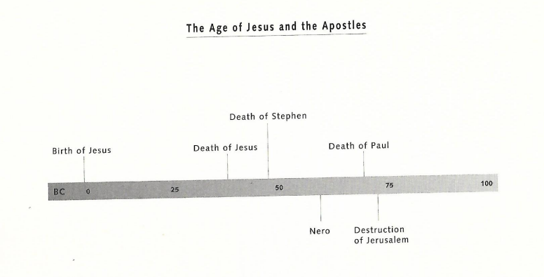
Credit: Shelly, Nelson Publishers, 1995

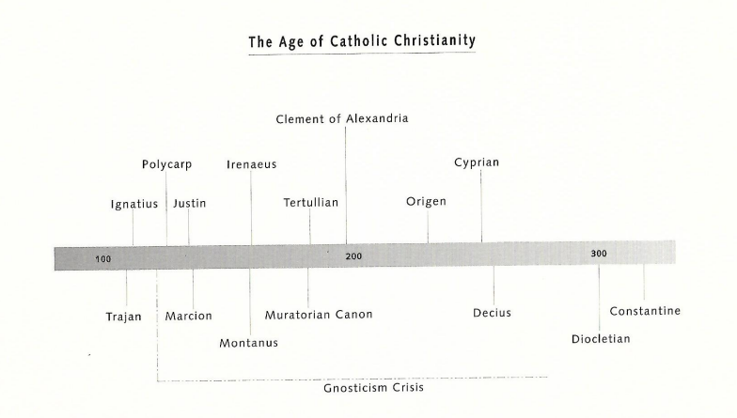
Credit: Shelly, Nelson Publishers, 1995

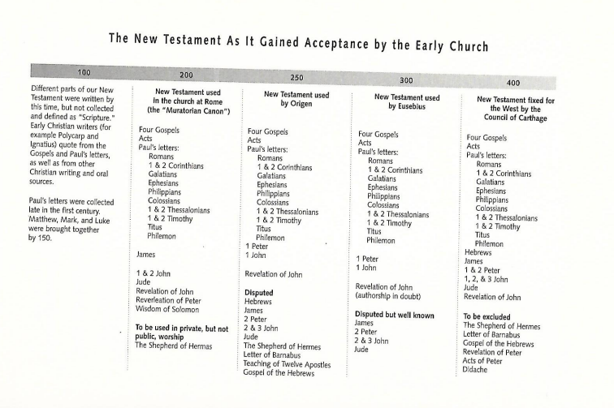
Credit: Shelly, Nelson Publishers, 1995

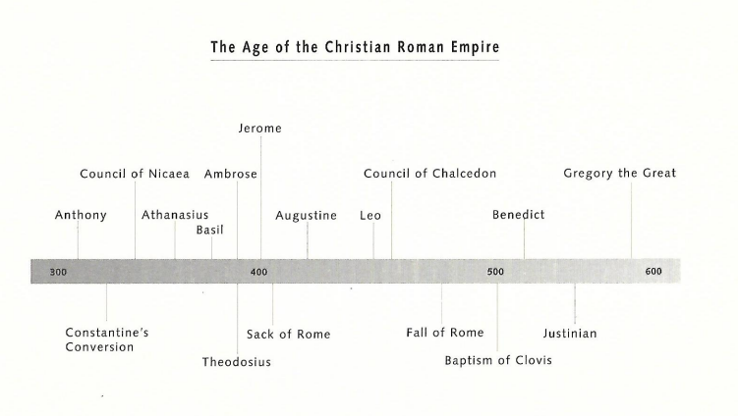
Credit: Shelly, Nelson Publishers, 1995

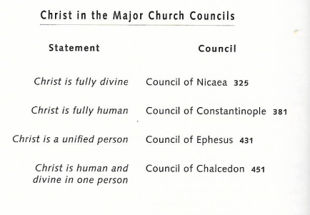
Credit: Shelly, Nelson Publishers, 1995

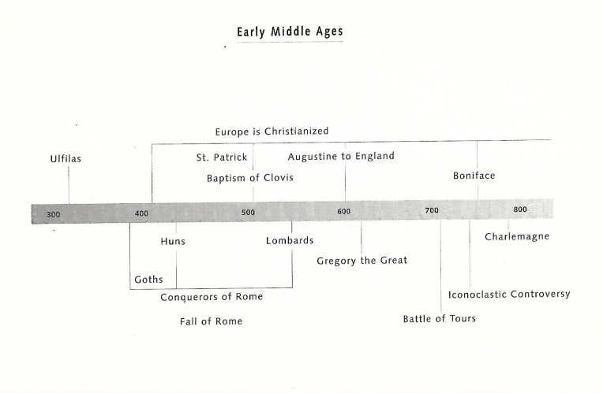
Credit: Shelly, Nelson Publishers, 1995

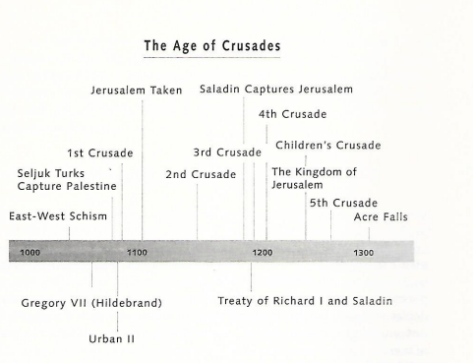
Credit: Shelly, Nelson Publishers, 1995

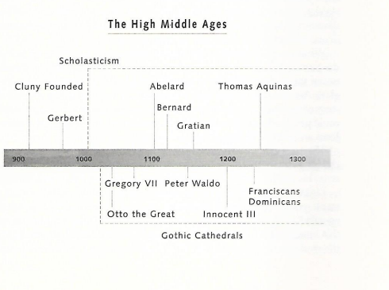
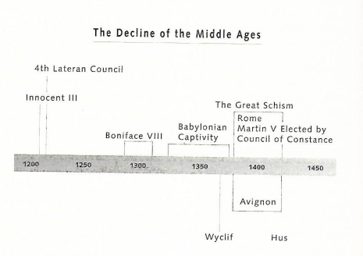
Credit: Shelly, Nelson Publishers, 1995

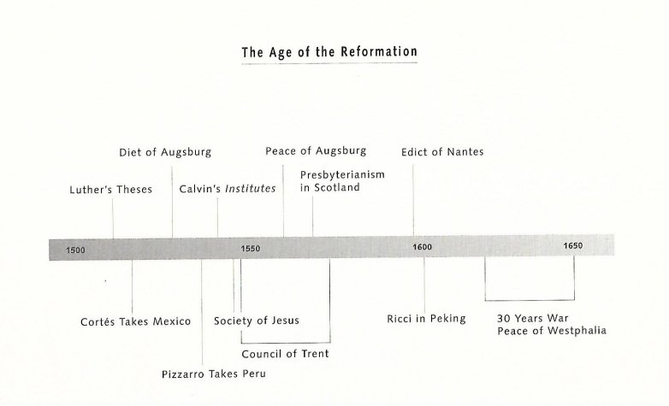
Credit: Shelly, Nelson Publishers, 1995

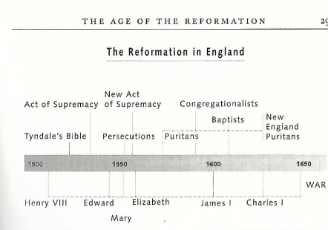
Credit: Shelly, Nelson Publishers, 1995

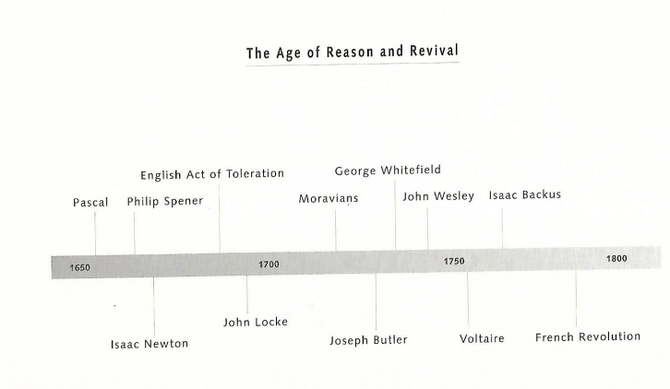
Credit: Shelly, Nelson Publishers, 1995

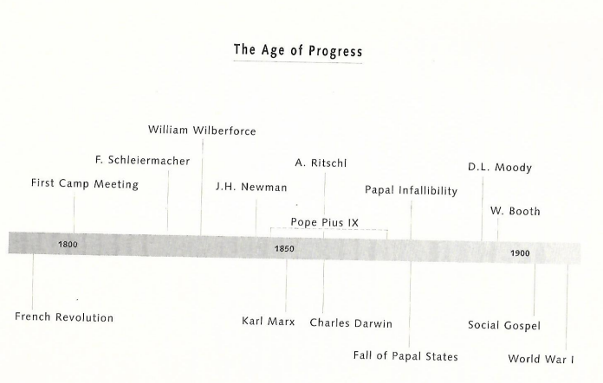Credit: Shelly, Nelson Publishers, 1995

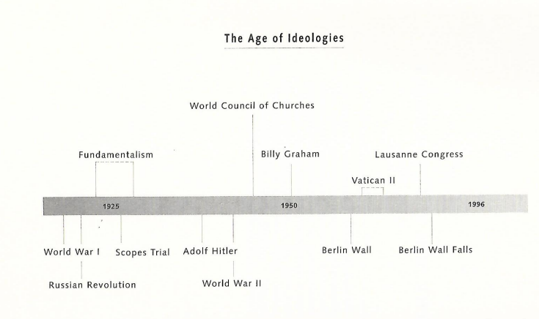
Credit: Shelly, Nelson Publishers, 1995

